Fluence-matching technique using photoacoustic radiofrequency spectra for improving estimates of oxygen saturation
Muhannad N. Fadhel, Eno Hysi, Hisham Assi, Michael C. Kolios*
Ryerson University, Department of Physics, Toronto, Canada
Institute for Biomedical Engineering, Science and Technology, Keenan Research Center, St. Michael’s Hospital, Toronto, Canada
*mkolios@ryerson.ca

Abstract:
Photoacoustic (PA) signals encode information about the optical absorption and spatial distribution of absorbing chromophores as well as the light distribution in the medium. The wavelength dependence of the latter affects the accuracy in chromophore quantification, including estimations of oxygen saturation (sO₂) with depth. We propose the use of the ratio of the PA radiofrequency (RF) spectral slopes (SS) at different optical wavelengths to generate frequency filters which can be used to match the fluence profiles across separate images generated with different optical wavelengths.
Proof-of-principle experiments were carried on a plastic tube with blood of a known oxygenation inserted into a porcine tissue. The algorithm was tested in-vivo in the hind leg of six CD1 mice, each under three different breathing conditions (100% O₂, room air and 100% CO₂). Imaging was done using the VevoLAZR system at the wavelengths 720 and 870 nm. The SS was calculated from the linear fit of the ratio of the photoacosutic RF power spectra at the two wavelengths. An ultrasound frequency filter was designed and applied to each segmented PA signal in the frequency domain and inversely transformed into the time domain to correct for the differences in the fluence profiles at both wavelengths. Linear spectral unmixing was used to estimate sO₂ before and after applying the ultrasound frequency filter.
The estimated blood sO₂ in the plastic tube for the porcine tissue experiment improved by 10.3% after applying the frequency filter when compared to the sO₂ measured by a blood gas analyzer. For the in-vivo mouse experiments, the applied sO₂ correction was 2.67, 1.33 and -3.33 % for every mm of muscle tissue for mice breathing 100% O₂, room air and 100% CO₂, respectively. The approach presented here provides a new approach for fluence matching that can potentially improve the accuracy of sO₂ estimates by removing the fluence depth dependence at different optical wavelengths.
- Introduction
Photoacoustic (PA) imaging has been one of the fastest growing modalities, as it can simultaneously deliver structural and functional information about blood vessels [1], [2]. The high optical absorption and weak ultrasound scattering of soft tissues allow for real time imaging with high contrast at depths and resolutions that cannot be matched by optical techniques.
Among the numerous applications of PA imaging [3], one of the main applications of PA imaging is mapping the spatial distribution of the chromophores inside biological structures [2], [4]–[6]. Hemoglobin, a major optical absorbing molecule in tissue, encodes functional information through changes in its biochemical structure. Detecting endogenous chromophores like hemoglobin allows one to generate tissue oxygenation maps, a routinely monitored physiological parameter used in diagnosis and monitoring the efficacy of various treatments [4], [6].
The resulting PA images primarily depend on the absorbing molecules present in the sample and the tissue optical illumination pattern. The absorption spectra of different forms of hemoglobin vary greatly for different optical wavelengths. By illuminating the sample with multiple optical wavelengths, estimations of the relative chromophore concentration can be achieved [7]. However, chromophore quantification is hindered by the dependence of the tissue light distribution on the different optical wavelengths [8].
Several tissue optical properties govern the light distribution in tissues, including the absorption coefficient$\left(μ_{a}\right)$, the scattering coefficient $\left(μ_{s}\right)$ and the anisotropy parameter $\left(g\right)$. These optical properties are a function of the optical wavelength [9]. The wavelength dependence of optical properties and how these properties change the light distribution in tissue introduces a challenge in accurately extracting the relative chromophore concentration.
Approaches for fluence compensation in PA imaging include correcting the light distributions using light diffusion models [10]–[12] or Monte Carlo simulations [13], both of which require prior knowledge of the tissue optical properties. Inverse iterative approaches can be used to estimate the optical properties [14]–[22], but this approach is computationally intensive. Recent work on using fluence eigenspectra can account for wavelength-dependent light attenuation [23], [24], but this increases the number of optical wavelengths required for imaging. Other methods include reference dye injection of known optical properties [25], the use of multiple light sources to estimate the fluence profile [18], [26]–[28] or a priori knowledge of tissue optical properties and their spatial distribution [29], all of which are difficult to implement for real-time imaging.
Regardless of the fluence correction method used, a suitable unmixing technique is required to estimate chromophore concentrations. Multiple methods have been proposed in PA imaging for unmixing samples with unknown chromophores and chromophores with known absorption profiles that differ from the background (e.g. nanoparticles) [30]–[33]. The most common method to quantify endogenous chromophores (e.g. hemoglobin) is linear spectral unmixing. Linear spectral unmixing assumes that the PA signals generated are due to a linear combination of the product of each optical absorber and its concentration [34]. Knowledge of the extinction coefficients of the chromophores present in the sample is necessary. Linear spectral unmixing has been used to quantify the relative concentration of oxy- and deoxyhemoglobin which can be used to assess oxygen saturation (sO₂) [8].
In PA oxygenation measurements, spectral coloring can result in errors in the accuracy of the estimated values [8]. For highly oxygenated tissue, the sO₂ maps decrease with depth relative to the actual oxygenation of the blood in tissue. This is due to the higher optical absorption of oxygenated hemoglobin as a function of wavelength in the NIR regime. The higher optical absorption results in a decrease in light fluence, and after applying linear spectral unmixing this will result in underestimation of tissue oxygenation. For highly deoxygenated tissues, the optical absorption of hemoglobin decreases as a function of wavelength in the NIR regime. After applying linear spectral unmixing, this results in an overestimation of oxygenation with depth. Improving the estimation of sO2 maps using PA imaging would be advantageous in biomedical imaging applications.
In ultrasound imaging, the ratio of the power spectra of the backscattered ultrasound signal to a reference signal has been used to estimate the ultrasound attenuation of a phantom [35], [36]. The advantage of using a reference signal is that this approach removes system dependent parameters that modify the ultrasound signal. Similarly, the ratio of the power spectra of the generated PA signals at multiple wavelengths can be used to estimate the difference in the optical attenuation. This is because as the optical penetration depth changes with wavelength, the frequency content of the PA signals also changes. A reference wavelength is selected and used to normalize the other wavelengths. If one assumes that for these wavelengths the same chromophores contribute to the PA signal, the change in the PA signal, especially at the lower ultrasound frequencies, are due to changes in the fluence patterns that are due to the different bulk optical properties. The ratio of the of the generated PA signals at multiple wavelengths has been used as a self-calibrating method to estimate the optical attenuation parameters and to correct for oxygenation estimates in tissues [37]–[40]. However, those proposed methods have been limited to PA microscopy and were used to image superficial vasculatures.
The purpose of this paper is to present a new method to match the fluence profiles of the acquired PA images at multiple wavelengths to improve sO₂ estimates. The difference in the optical fluence between the images at the two wavelengths can be extracted from the ratio of the power spectra calculated of the radiofrequency (RF) signals. This can be used to match the fluence profiles of the images at the two wavelengths without the need to prior knowledge of the geometrical shape of the absorbing chromophores.
- Description of fluence matching approach
Pervious work has shown that the acoustic spectra ratio of PA signals at two different optical wavelengths can be used to extract information about the absolute optical absorption of dye and oxygen saturation of hemoglobin in tissues [37]–[39]. These seminal studies demonstrate that the frequency of PA signals encodes information related to the optical fluence of the surrounding tissues. The main assumption incorporated into these approaches is that the reduced scattering coefficient is much smaller than the absorption coefficient. This limits the application of the models to optical wavelengths (500 - 600 nm) of high absorption that can only be used in PA microscopy imaging.
For those reasons, the proposed fluence matching approach in this paper uses information directly extracted from the acoustic spectra ratio of the PA signal. However, our fluence matching model does not require the assumption mentioned above. A well-controlled test phantom is introduced to further investigate the correlation between the acoustic spectra ratio to the effects of optical fluence at two optical wavelengths. The phantom is imaged at higher optical wavelengths (680 – 910 nm) that can be used to examine deeper tissues in PA imaging. The concept of the acoustic spectral ratio in PA imaging is introduced below.
The received ultrasound signal carries information about the initial pressure rise, the system used ($H$), and the ultrasound attenuation ($α$) the medium pulse propagates through. For the convenience of the reader, a brief review of the representation of ultrasound power spectra can be found in [37], [38], [41]–[44]. The detected ultrasound signal has spectral power $S$ and can be described as:
 | $$S(ω, λ)= p(ω, λ)H(ω)α(ω)$$ | (1)
where $ω$ is the ultrasound angular frequency $p$ is the received pressure rise detected by the transducer. By imaging the sample using two different optical wavelengths, the impact of the system dependent parameters ($H$) can be eliminated as previously done in ultrasound imaging [35], [36], [41], [44] and later adapted in PA imaging by taking the ratio of the power spectra at two different optical wavelengths [37], [38]. This ratio can be represented as:
 | $$\frac{S(ω, λ_{1})}{S(ω, λ_{2})} = \frac{ p(ω, λ_{1})H(ω)α(ω)}{p(ω, λ_{2})H(ω)α(ω)} = \frac{ p(ω, λ_{1})}{p(ω, λ_{2})}= \frac{\left.ϕ\left(ω, λ_{1}\right)μ_{a}(ω,λ_{1}\right)}{\left.ϕ\left(ω, λ_{2}\right)μ_{a}(ω, λ_{2}\right)}$$ | (2)
After the mathematical cancellation of these parameters, the ratio of the power spectra can be thought of to represent the ratio of the received PA pressure ($p$), which conveys information related to the absorption coefficient ($μ_{a}$) and light fluence ($ϕ$) [45].
Knowing that changes in the frequency content of the ratio of the power spectra does carry information about the changes in the optical fluence at the imaged wavelengths, a test phantom is introduced to further investigate this relationship.
Measuring this change in the optical fluence can then be used to match the fluence profile of the images at the imaged wavelengths. A schematic diagram of fluence matching method is shown in Figure 1. We propose to use this method to improve spectral unmixing for the accurate assessment of oxygen saturation.
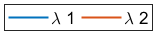

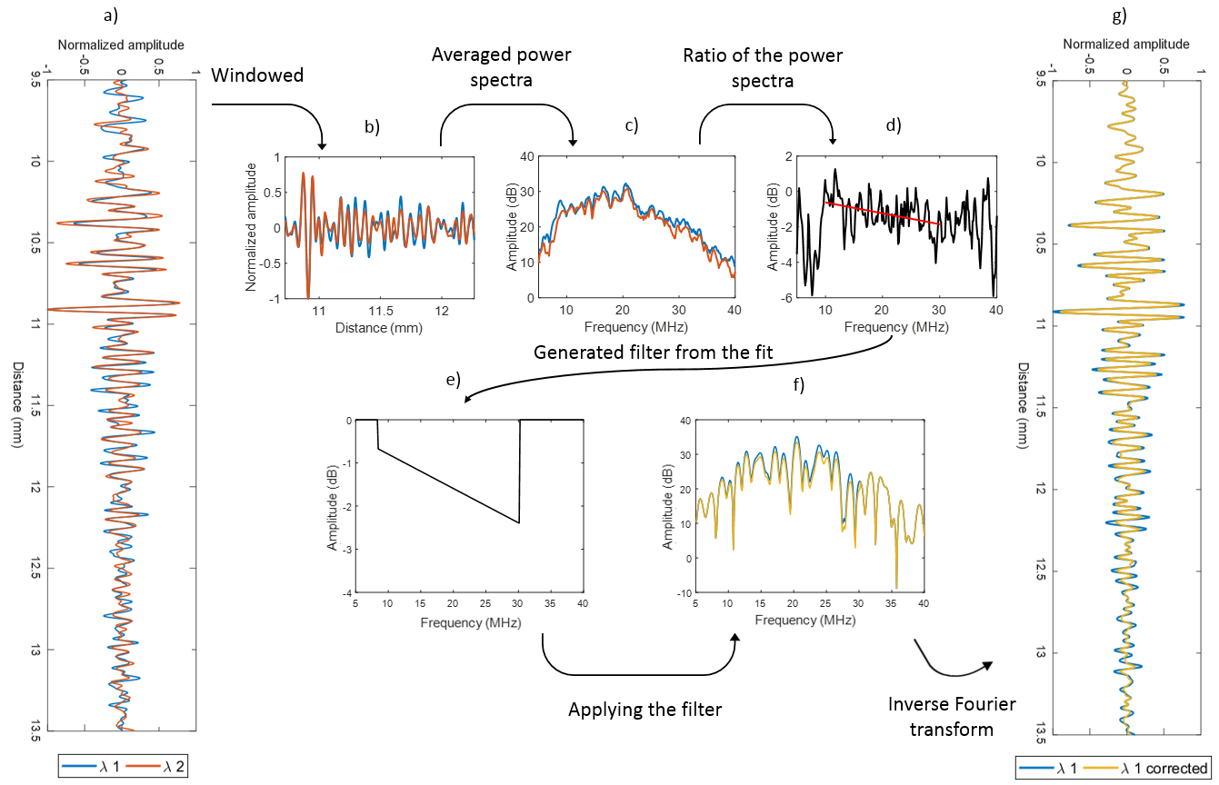
Figure 1: Representation of fluence matching method. (a) The normalized RF signals acquired at the two wavelengths (blue, red). (b) The windowed RF signals from (a). (c) Averaged power spectral of the neighboring 20 RF in (b). (d) The ratio of the power spectra shown in (c). (e) The generated frequency filter from the cumulative spectral slope (SS) of the ratio of the power spectra in (d). (f) Applying the generated frequency filter in (e) to the power spectra of the RF signal shown in (b). Blue is before applying the frequency filter and yellow is after applying the frequency filter. (g) The generated RF signal after applying the frequency filter in yellow. Original signal shown in blue.

- Materials and methods
This section summarizes the sample preparation methods, the system used for PA imaging and the procedures applied for fluence matching and spectral unmixing in ex-vivo tissues and mice in-vivo.
  - Test phantom to examine the generated frequency filter
Test phantom was used to validate the dependence of the changes in the frequency content on the alteration in fluence that need to be compensated for to improve oxygenation estimates at the optical range of 680 – 950 nm. The phantom was prepared by heating degassed water into 80ºC. 10% by volume of gelatin porcine skin (Sigma Aldrich, St. Louis, Missouri, United States) was added, mixed and left to cool down. At 37ºC 5% of intralipid (Sigma Aldrich, St. Louis, Missouri, United States) and 5% of blood (Canadian blood services, Alberta, Canada) by volume were added, and the phantom was left in the fridge. The blood sample was mixed in a test tube prior to use to increase its oxygenation state.
Next day the phantom was immersed into a water bath at 37ºC and placed on top of a microscope slide coated with 20 nm of gold. This setup is similar to insertion loss method used to measure ultrasound attenuation of a phantom [46]. The test phantom was imaged using the VevoLAZR system (FujiFilm-VisualSonics Inc., Toronto, CA) coupled with the LZ250 transducer. The gain was adjusted to prevent the signal of the gold to be over saturated. The gold platted microscope slide was imaged in the absence and presence of the test phantom at the wavelengths 720 nm and 870 nm with 20 frames for each wavelength. ROI were applied to select the signal acquired from the gold platted microscope slide. By comparing the signal amplitude of the images acquired of the microscope slide alone and the images acquired of the microscope slide with the test phantom, the fluence which need to be compensated for at those two wavelengths due to the presence of the test phantom was measured. The ratio of the power spectra at the two imaged wavelengths were calculated. The line best fit was computed (spectral slope (SS)) at the -6 dB of the transducer bandwidth. The SS value was measured and used to generate the frequency filter as discussed in section 3.4 and shown in Figure 1. The alteration in the signal amplitude after applying the frequency filter was measured and compared to the amplitude modified due to the presence of the test phantom as discussed above.
  - In-vivo sample preparation
Porcine tissue was acquired from a local grocery store. A plastic tube of 350 µm in diameter was inserted into the porcine tissue at approximately 5 mm below the tissue surface. Three different blood samples were prepared in EDTA coated vacutainers (Fisher Scientific, Hampton, USA). The blood was acquired from female CD1 mice using cardiac puncture (animal protocol: ACC 788). The first sample was prepared by gently mixing the vial to increase the oxygenation of the blood. The second sample was prepared by adding 1 mg of Sodium Nitrite (Sigma-Aldrich Inc., Canada) to 1 mL of blood to decrease its oxygenation. The final sample was prepared by mixing 0.5 ml of first sample with 0.5 ml of the second sample. All three samples were injected into the respective plastic tube separately and imaged using the VevoLAZR system. The oxygenation of the blood in each vial was measured prior to imaging using a blood gas analyzer (Radiometer Medical, London, CA).
Female CD1 mice (Charles River, Toronto, CA) aged 7-8 weeks and weighing 25-30 g were used. The hair on the mouse hind leg were removed using hair removal products (Nair) prior to imaging. All the experimental protocols in this study were approved from the Animal Care Committee at St. Michaels Hospital and the Research Ethic Board at Ryerson University (protocol #788).
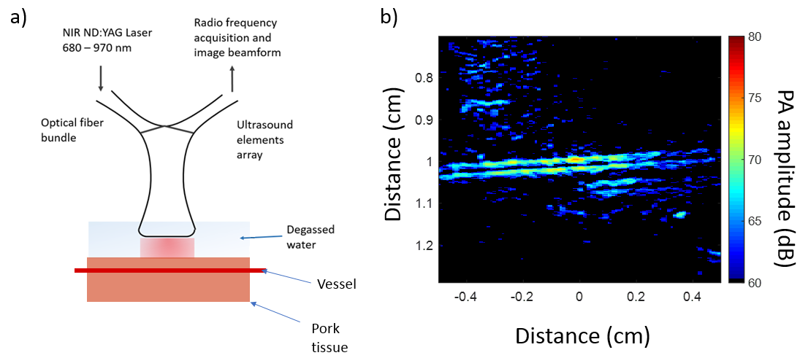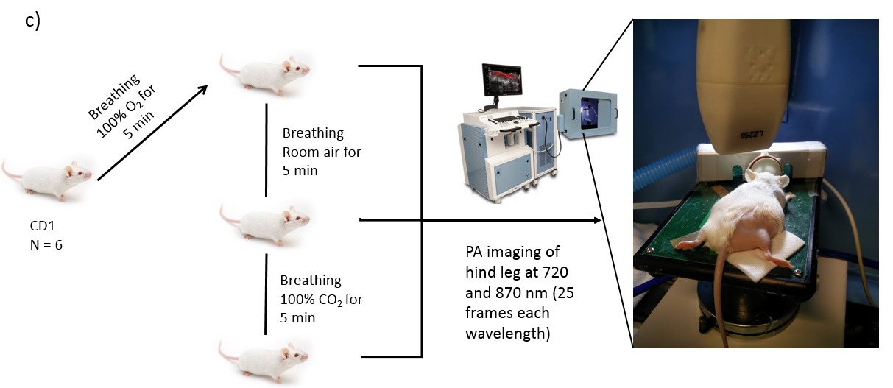
Figure 2: (a) Schematic representation of the PA system used for vessel imaging. (b) Representative PA image acquired at 720 nm using a 21 MHz transducer. (c) Schematic representation of the experimental setup used for imaging the CD1 mice. The mice were exposed to three different oxygenation states of 100% O₂, room air and 100% CO₂. The hind legs were shaved and imaged using the VevoLAZR system with liquid gel as a coupling media (not shown in the image).
  - Photoacoustic Imaging
The two samples (the porcine tissue with the plastic tube and the mice) were imaged using the commercial VevoLAZR PA system as shown in Figure 2a, c. Ultrasound liquid gel was used as a coupling media. A heating platform was used to monitor the temperature to be within 37 ± 0.5ºC. The same platform was also equipped with electrocardiography leads for monitoring the respiratory and heart rate of the mice during imaging. A 100 mW heating lamp was used to maintain a physiological temperature for the mice during anesthesia. The LZ-250 linear array PA transducer with a center frequency of 21 MHz was used for imaging. All mice were anaesthetized with a flow of isofluorane (1.5%) in air at 0.5-1 L/min. The breathing air was altered for each mouse starting with 100% O₂ before switching to room air and terminating with 100% CO₂ inducing asphyxiation. A period of 5 min was allowed for each breathing condition to ensure stabilization prior to imaging (Figure 2c). All samples were imaged at 720 and 870 nm, and 25 frames at the same location (frame rate 5/sec) were acquired for each images at the two wavelengths. The pre-beamformed RF signals were extracted from the system and beamformed using a delay-and-sum algorithm.
  - Procedures for fluence matching
To match the fluence profile of a PA image acquired at 720 nm to a PA imaged acquired at 870 nm, a moving rectangular window of size 0.77 × 1.80 mm (10 times the ultrasound wavelength) with 66% axial overlap was applied to the time domain PA signals at each wavelengths (Figure 3). The windowed beamformed RF signals were transformed to the frequency domain using the Fast Fourier Transform. Averaging of 20 neighboring power spectra (or 1.80 mm) was applied for 25 frames at each wavelength. The ratio of the average power spectra acquired at 870 nm and 720 nm were calculated, and a line best fit was used to estimate the SS within the bandwidth of the transducer (8.5 to 31.5 MHz) in the logarithmic scale (Figure 3). The cumulative SS was computed by integrating the measured SS as a function of depth.

The cumulative SS was used to design the frequency filters. The filters were composed of an antilog value to the cumulative SS at the bandwidth of the transducer. Outside the bandwidth of the transducer a value of one were assigned to the filters. The filters carry information about the ratio of the optical fluence profiles of the images at the two wavelengths ($ϕ_{2}/ϕ_{1}$). The filter was applied to the PA image acquired at 720 nm. An inverse Fast Fourier Transform was applied to transform the signals back to its time domain.
This method was applied on the PA images acquired at 720 nm to match the fluence profile of PA imaged acquired at 850 nm (a summary of fluence matching method is shown in Figure 1). Linear spectral unmixing was performed before and after applying the proposed fluence matching method to quantify the sO₂ values.
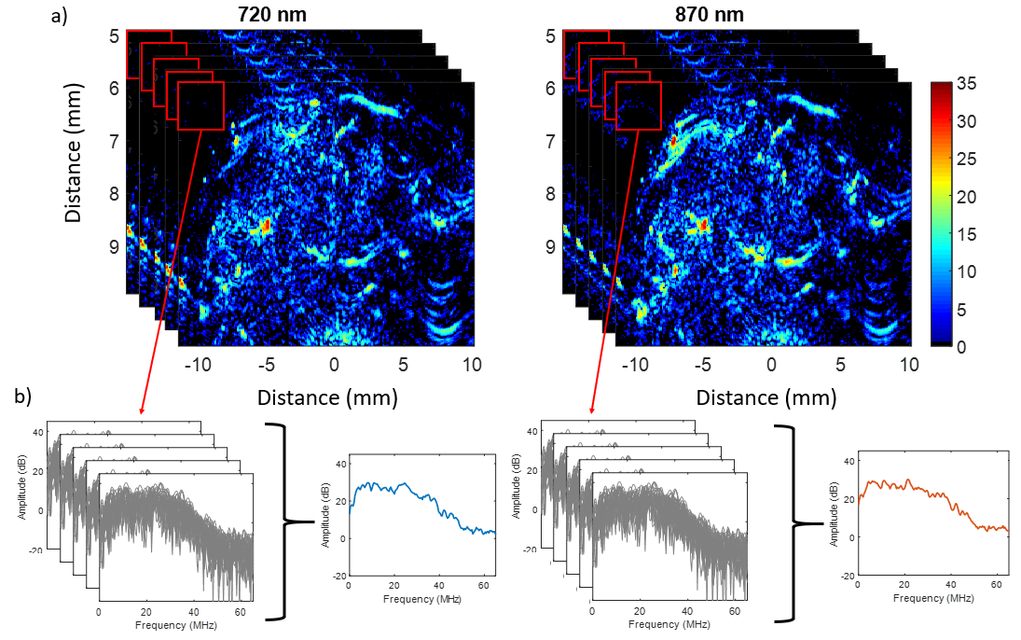
Amplitude (dB)
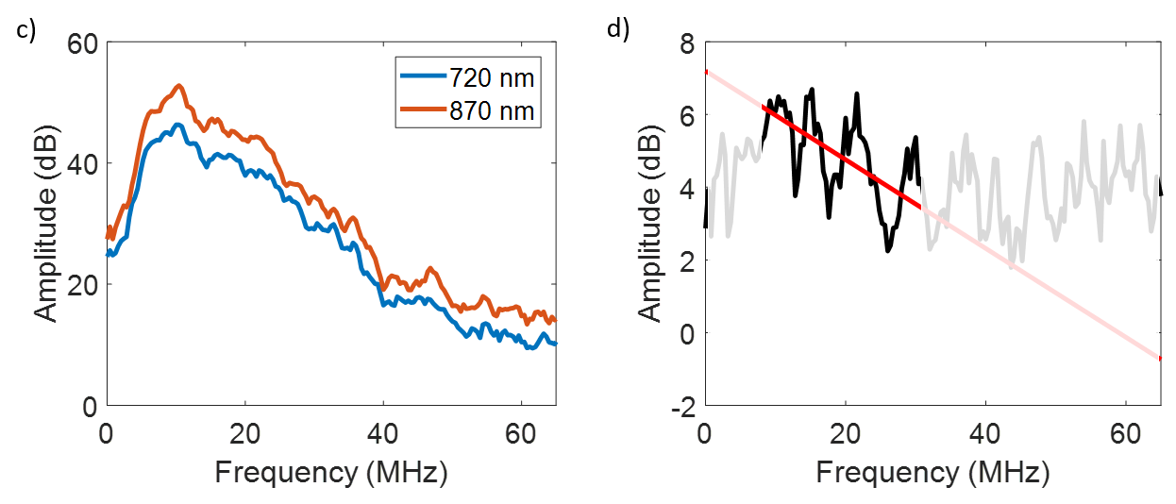
Figure 3: Procedures used in the fluence matching method for the images acquired from a mouse hind leg at two wavelengths used to calculate the normalized averaged power spectra. (a) Thresholded PA images acquired at the 720 and 870 nm with 25 frames collected for each wavelength (in the image only 5 frames are showing for illustrative purposes). A moving rectangular window sized 0.77 × 1.80 mm was applied. (b) the normalized power spectra of the selected window in (a) are shown in gray for the images at the two wavelengths (which represent background noise). The averaged power spectra for 720 and 870 nm wavelengths are shown in blue and red, respectively. (c) Representative of the normalized averaged power spectra calculated. (d) the ratio of the power spectral shown in (c) with the line best fit within the bandwidth of the transducer (solid black line).

  - Spectral unmixing
To quantify the sO₂ values form the PA images, linear spectral unmixing was applied after thresholding the PA image using Otsu’s threshold [47]. For wavelength (λ₁) the generated PA signal can be represented as:
 | $${ p_{λ_{1}}= Γ ϕ_{λ_{1}} [C}_{HbO_{2}}ε_{HbO_{2}λ_{1}}+C_{Hb}ε_{Hbλ_{1}}]$$ | (3)
where,$Γ$ is Grüneisen parameter,$ϕ$ is the light fluence, $C_{HbO_{2}}, { C}_{Hb}$are the concentration of the oxy-, deoxyhemoglobin in the sample, respectively and $ε_{HbO_{2}λ_{1}}, ε_{Hbλ_{1}}$are the extinction coefficients of oxy-, deoxyhemoglobin from previously published measurements [48]. In the case of multiple wavelengths, the equation above can be re-written in matrix notation:
 | $$Γ \left[\begin{matrix}{ϕ_{λ_{1}}ε}_{HbO_{2}λ_{1}} & {ϕ_{λ_{1}}ε}_{Hbλ_{1}} \\ {ϕ_{λ_{2}}ε}_{HbO_{2}λ_{2}} & {ϕ_{λ_{2}}ε}_{Hbλ_{2}}\end{matrix}\right]\left[\begin{matrix}C_{HbO_{2}} \\ C_{Hb}\end{matrix}\right]∝\left[\begin{aligned}\begin{matrix}p_{λ_{1}} \\ p_{λ_{2}}\end{matrix}\end{aligned}\right]$$ | (4)
The equation takes the form $Ax = b$, where $A$ is the product of the Grüneisen parameter with the fluence and extinction coefficients, $x$ is the concertation of the chromophores in the sample (the unknown parameters) and $b$ is measured PA pressure matrix. By implementing fluence matching, equation (4) can be re-written as:
 | $$ϕ_{λ_{2}}Γ \left[\begin{matrix}ε_{HbO_{2}λ_{1}} & ε_{Hbλ_{1}} \\ ε_{HbO_{2}λ_{2}} & ε_{Hbλ_{2}}\end{matrix}\right]\left[\begin{matrix}C_{HbO_{2}} \\ C_{Hb}\end{matrix}\right]∝\left[\begin{aligned}\begin{matrix}p_{λ_{1}} \\ p_{λ_{2}}\end{matrix}\end{aligned}\right]$$ | (5)
The solution was limited to positive values to avoid negative concentrations and the sum of all the chromophores at a selected location was set to 1. These two restrictions can be represented by $0<{C_{Hbo_{2}}, C}_{Hb}<1$ and ${C_{Hbo_{2}}+ C}_{Hb}=1$, respectively [4]. Finally, the mean square error of the measured and calculated pressure is minimized to solve for the chromophores concentrations.

To assess the proposed fluence matching method, multiple ROIs were selected for each PA image. The ROIs were selected using the PA images acquired at 870 nm wavelength. Five to fifteen vessels were segmented for each image. The change in the average oxygenation before and after applying the fluence matching method was computed and plotted as a function of depth from the skin surface. This was done for each oxygenation state.

- Results and discussion
This section displays the results of fluence matching approach on the ex-vivo porcine tissue and in-vivo muscle tissue of mice and the discussion associate with it.
4.1. Test Phantom to validate fluence matching approach
The ultrasound and PA images acquired of two designed setups are shown Figure 4 for the wavelengths 720 and 870 nm. The first setup is imaging gold platted microscope slide and the second setup is imaging the same gold platted microscope slide with a tissue mimicking phantom placed on top of it. From the ultrasound images the setup can be seen for the gold platted microscope slide and the test phantom used. The PA images display only the gold platted microscopic slide as gold has much higher optical absorption relative to the test phantom. From Figure 4 (b, c) it can be seen that gold has a similar optical absorption at the imaged wavelengths, however this was not observed when a test phantom was introduced between the transducer and the gold platted microscopic slide (Figure 4 e, f). This is due to change in optical fluence of light as it propagates through the phantom. The power spectra computed from the PA RF signals of the two setups shown in Figure 4 are shown in Figure 5 (a, d). The ratio of the power spectra at the two imaged wavelengths for the two setups are shown in Figure 5 (b, e). It can be seen that in case of only the gold platted microscope slide, the ratio of the power spectra does not demonstrate any correlation with the ultrasound frequency (Figure 5b). For the second case when the test phantom is present, the ratio of the power spectra does demonstrate dependence with the ultrasound frequency (Figure 5e). This demonstrate the impact of the optical fluence on the acoustic spectral ratio.
Figure 4: (a-c) imaging of the gold platted microscope slide alone and (d-e) imaging the test phantom placed on top of the gold platted microscope slide using the VevoLAZR system. The ultrasound (a, d), PA image at 720 nm (b, e) and PA image 870 nm (c, f) of two different geometrical setups.
Fluence loss due to the present of the test phantom was calculated by comparing the measured signals from the gold at the two different optical wavelengths in the presence and absence of the test phantom. The change in the optical fluence at the two imaged wavelengths in the presence of the test phantom was measured to be 11.2 ± 0.6 dB. Fluence matching method was applied to compensate in the fluence loss at the 870 nm wavelength. The change in the amplitude of the PA signal at 870 nm after applying the frequency filter in Figure 5c. The comparisons of the PA signal amplitude at the imaged wavelengths 720 nm and 870 nm, and PA signal amplitude at 870 nm after fluence matching is show in Figure 5f. It can be seen that after applying the proposed fluence matching approach the PA signal amplitude at 870 nm is close to the PA signal amplitude at 720 nm. This demonstrate the capability of the fluence matching approach in compensating for fluence loss.
Figure 5: (a, d) are the power spectra of the PA signals acquired from gold platted microscope slide from the two setups shown in Figure 4. (b, e) are the ratio of the two power spectra in (a, d) respectively. (c) is the corrected PA image at 870 nm after applying the fluence matching approach. (f) compares the PA signal amplitudes at 720 nm, 870 nm and the corrected PA signal at 870 nm.
Here we are exploring the use of a simple, easy-to-use linear filter that can correct for the effects of optical fluence. Using a highly scattering phantom (Figure 4) positioned over a strongly absorbing gold film, we demonstrate how the optical fluence changes at two wavelengths of illumination (720 nm and 870 nm) alters the PA power spectra. As show in Figure 5, the optical fluence broadens the frequency spectrum at the lower optical absorption (in this case 870 nm). This change was used here to detect the fluence difference between the two imaged wavelengths and compensated for accordingly as shown in Figure 5 f.

4.2. Ex-vivo porcine tissue
The sO₂ maps of the samples measured before and after applying the fluence matching method for oxygenated and deoxygenated blood samples are shown in Figure 6a. The estimated sO₂ of the blood before applying the fluence matching method is lower than the oxygenation as measured using the blood gas analyzer for oxygenated blood and higher for the deoxygenated blood. This result was expected because of spectral coloring of tissue with depth [8]. After applying the fluence matching method, the estimated sO₂ values were closer to the oxygenation values measured with the blood gas analyzer. These changes are summarized in Figure 6b. The percent difference between the blood gas analyzer measurements and the sO₂ estimate before applying fluence matching were 18.3%, 16.7% and 12.2% for the oxygenated, mixed and deoxygenated blood samples, respectively. The differences after applying the fluence matching method were 4.7%, 5.1% and 6.6%, respectively. This demonstrates the capability of the fluence matching method to improve the estimated sO₂ with depth.
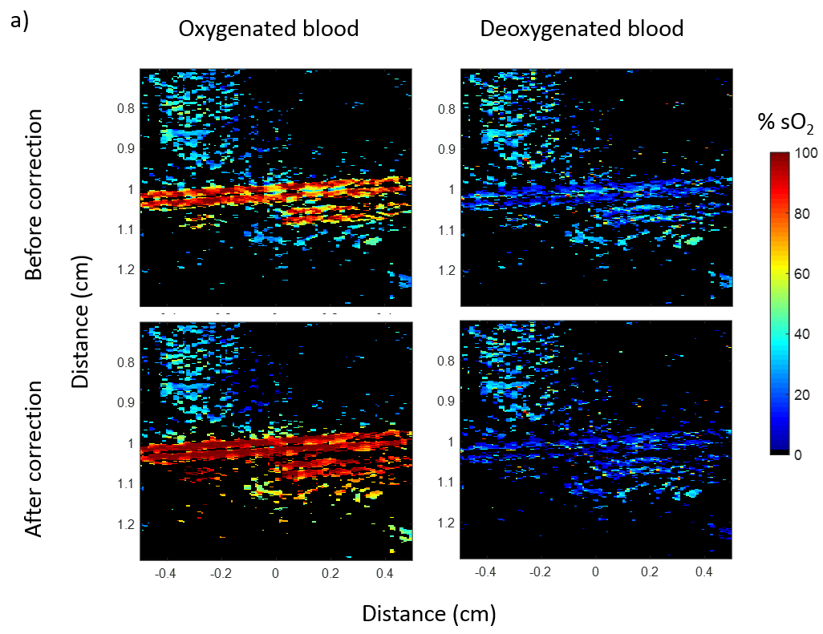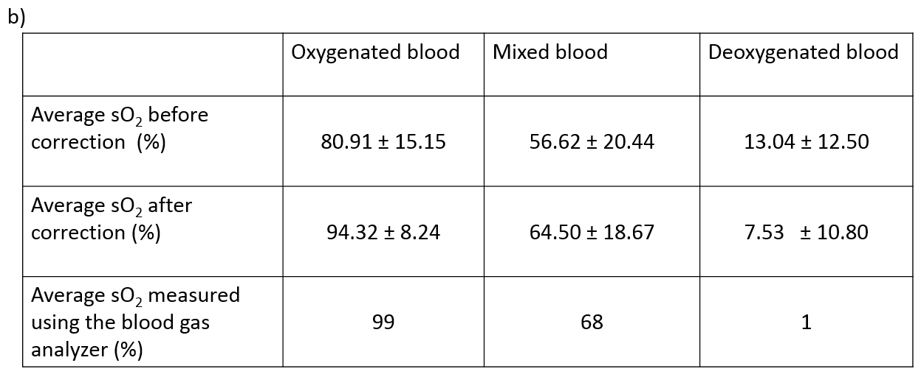
Figure 6: (a) PA sO₂ maps for oxygenated and deoxygenated blood samples in a plastic tube inserted into porcine tissue before and after applying fluence matching method. (b) Average sO₂ values measured for a blood samples in a plastic tube inserted into porcine tissue before and after applying fluence matching method. The same blood samples were measured using the blood gas analyzer.
4.3. In-vivo Muscle tissue
The fluence matching method was tested on six different CD1 mice. Each mouse was imaged under three different breathing conditions of 100% O₂, room air and 100% CO₂. The ratio of the SS was calculated as demonstrated in Figure 3. The measured SS and the cumulative SS maps are presented in Figure 7 for a representative mouse breathing 100% O₂ (left panels) and 100% CO₂ (right panels). Negative SS values were more common when the mouse was breathing 100% O₂ while positive SS values were more common when the mice were breathing 100% CO₂. The correction factor applied for mice breathing 100% O₂ is reversed compared to the correction factor applied for mice breathing 100% CO₂. This is also reflected in the cumulative SS shown in Figure 7b. The greater values for the cumulative SS measured, the greater the necessary correction for the PA signal amplitude.
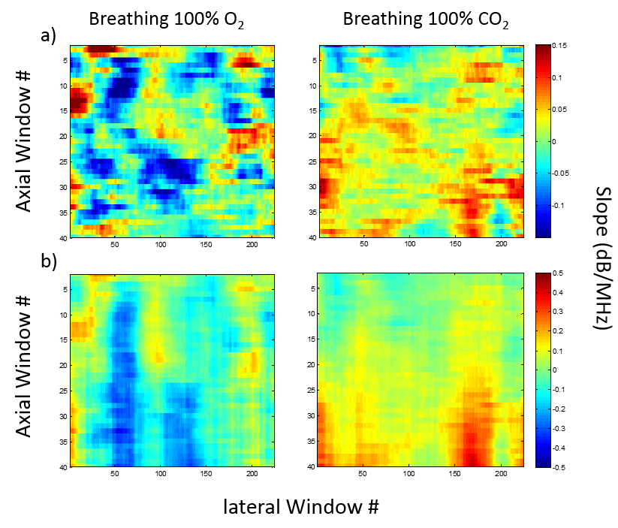
Figure 7: (a) Spectral slope maps calculated using the proposed method for fluence matching, (b) the cumulative spectral slope maps with depth calculated from (a). Each calculated slope is used to create a frequency filter at that depth.
The calculated cumulative SS shown in Figure 7 was used to construct the frequency filter applied to the power spectra (within the limits of the transducer bandwidth). The effect of applying the frequency filter on the RF data is illustrated in Figure 8. The time domain RF signals of a mouse breathing 100% O₂ before and after the matching is shown through the use of inverse Fourier Transform (Figure 8). As expected the amplitude of the PA signal decreased with depth before the matching. After applying the frequency filter, the rate of the decrease of the PA signal as a function of depth increases. The filters were applied to the PA RF data acquired at 720 nm. The goal of the filter was to match the fluence profile of 720 nm to that at 870 nm. The signals at 870 nm were not modified.
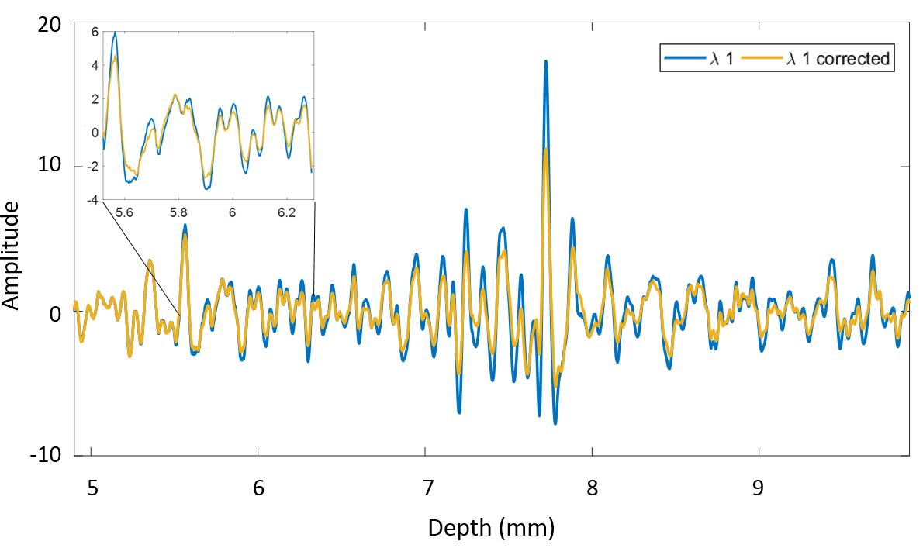
Figure 8: Representative RF signals (acquired at 720 nm) for a mouse breathing 100% O₂ before and after fluence matching. Applying the frequency filter decreases the amplitude of the PA signal with depth.
The resulting sO₂ maps after applying linear spectral unmixing on the thresholded PA images are presented in Figure 9. For superficial vessels (white arrows), the estimated sO₂ before and after applying fluence matching method is comparable for the three breathing states. For deeper vessels (red arrows), the differences in the estimated sO₂ between the two methods become more pronounced. For mice breathing 100% O₂, the estimated sO₂ becomes higher after correction, while for mice breathing 100% CO₂, the estimated sO₂ becomes lower after correction. This was expected as the effect of spectral coloring is inverted for normoxic and hypoxic mice. Specifically, the optical absorption coefficient for oxygenated blood is higher at 870 nm than at 720 nm while for deoxygenated blood the opposite trend holds. For mice breathing room air, the trend is closer to that of mice breathing 100% O₂, albeit the correction is smaller.
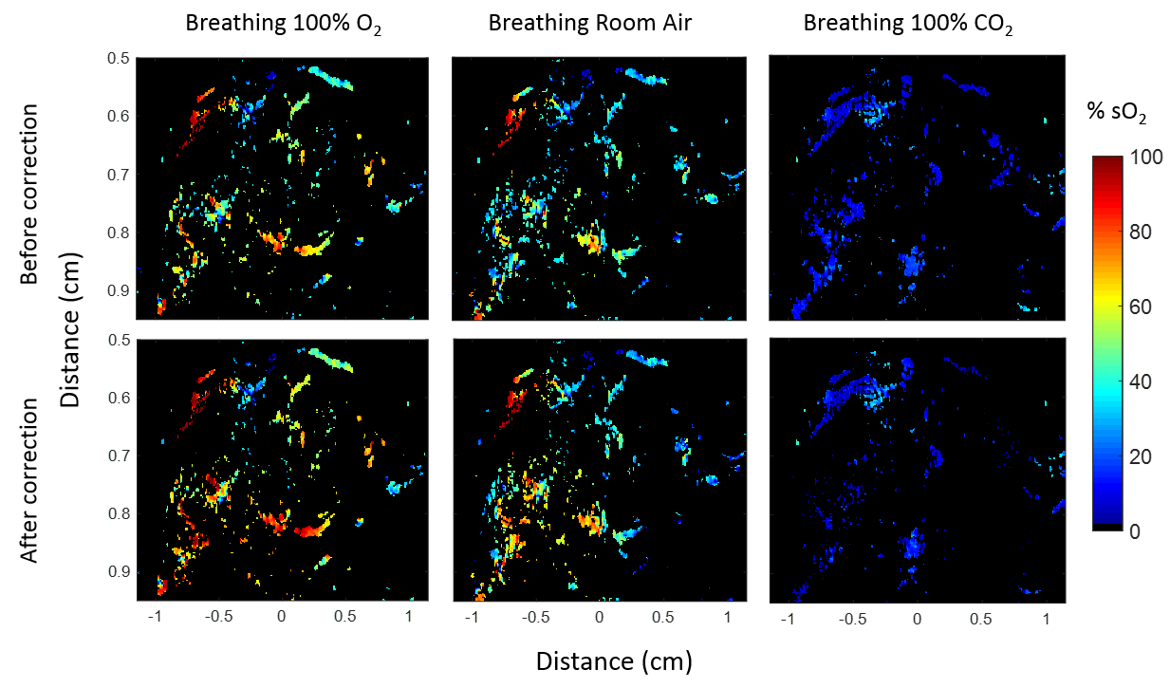
Figure 9: sO₂ maps acquired using 720 and 870 nm wavelengths before and after applying fluence matching method for mice breathing 100% O₂, room air and 100% CO₂.
To examine the oxygenation of vessels in all the imaged mice, ROIs were applied to select multiple vessels at different depths in the PA images. The average sO₂ values were computed for each ROI. The change in the estimated sO₂ before and after applying the matching filter is plotted as a function of depth from the skin. Representative data of a mouse breathing 100% O₂ are shown in Figure 10a, where each star represent one selected vessel ROI. The line best fit is also plotted to demonstrate the trend (Figure 10b).
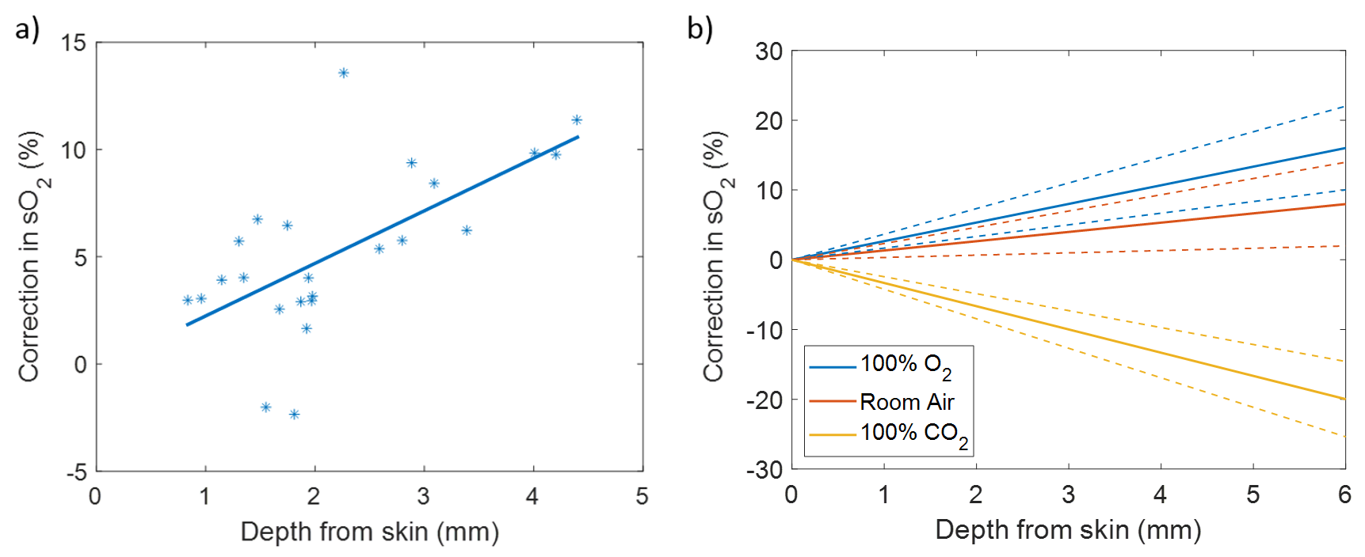
Figure 10: (a) The relative changes in the estimated sO₂ as a function of depth before and after applying the fluence matching method for multiple ROIs of a mouse breathing 100% O₂. The line represents the line best fit for the data. (b) The average of the line best fit for all the 6 mice for mice breathing 100% O₂, room air and 100% CO₂. The dashed lines represent the standard deviation of the slope for each fit.
The average of the fitted slopes (Figure 10a) of the six mice and the standard deviations are plotted in Figure 10b for all three mice breathing states. The results show an increase in the SO₂ measurements with depth for the mice breathing 100% O₂ and room air of 2.67 and 1.33 % per mm and a decrease in the SO₂ with depth for mice breathing 100% CO₂ of 3.33 % per mm. The correction needed for the mice breathing 100% O₂ was higher than that for mice breathing room air. This was expected as room air contains an average of 21% O₂ which will result in less oxygenated blood. For less oxygenated blood, the ratio of the absorption coefficients at 870 to 720 nm decreases [8], [14]. For mice breathing 100% CO₂, the trend was reversed due to the ratio of the absorption coefficient at 870 to 720 nm being opposite for deoxygenated blood. In addition, the amplitude of the correction for mice breathing 100% CO₂ was the highest. The reason behind it is that in mice breathing 100% O₂ and room air, fewer oxygenated blood vessels are present due to the consumption of tissue to oxygen (Figure 9 blue arrows). However, for mice breathing 100% CO₂, all vessels are expected to be deoxygenated.
4.4. Assumptions of fluence matching method
This work demonstrates the capability of using the ratio of the power spectra to compensate for the fluence loss using ultrasound focused PA system. One of the assumptions used in the fluence matching approach is the linearity in the fit at the bandwidth of the transducer of the ratio of the two-power spectral. Although previous works has demonstrated that the ratio of the power spectra at two different optical wavelengths can take a sigmoidal shape for specific geometrical setup [37], [38]. The ultrasound transducer used in these experiments has smaller bandwidth, at the bandwidth of our transducer (10-30 MHz), the ratio of the power spectra is a linear function of frequency (R² = 0.95) as can be seen from Figure 5e.
The second assumption used in the proposed fluence matching approach, is that the spatial distribution of the chromophores at the two imaged wavelengths is invariant and can be eliminated when the ratio of the power spectra is computed. This can be further explained through representing the absorption coefficient by two parameters one is optical wavelength dependent ($A\left(λ_{1}\right)$) and one is ultrasound frequency dependant ($B(ω)$) such that $μ_{a}\left(ω,λ_{1}\right)= A\left(λ_{1}\right)B(ω)$. Since the main absorbers in blood is dominated by hemoglobin at the imaged wavelengths, the spatial dependence due to the optical wavelength is the same. The spatial dependence of the chromophores can be converted into time dependence in the generated PA signals through the speed of sound which will be reflected in the frequency domain through the power spectra. This allow re-writing equation 2 such that:
 | $$\frac{S(ω, λ_{1})}{S(ω, λ_{2})} = \frac{\left.ϕ\left(ω, λ_{1}\right)A\left(λ_{1}\right)B(ω\right)}{\left.ϕ\left(ω, λ_{2}\right)A\left(λ_{2}\right)B(ω\right)} = \frac{\left.ϕ\left(ω, λ_{1}\right)A(λ_{1}\right)}{\left.ϕ\left(ω, λ_{2}\right)A(λ_{2}\right)}$$ | (6)
since the power spectra are represented in the log domain, the above equation can be modified to:
 | $$\log_{10}\left[\frac{S(ω, λ_{1})}{S(ω, λ_{2})}\right]=\log_{10}\left[\frac{ϕ\left(ω, λ_{1}\right)}{ϕ\left(ω, λ_{2}\right)}\right]+\log_{10}\left[\frac{\left.A(λ_{1}\right)}{\left.A(λ_{2}\right)}\right]$$ | (7)
by applying a linear fit of slope (m) and y-intercept (b) to the logarithmic form of Equation 7, the changes in the frequency content (SS) of the ratio of PA power spectra at two different optical wavelengths (of the same absorbing chromophores spatial distribution) can be attributed to changes in the optical fluence at these two optical wavelengths. This difference in optical fluence (due to the different fluence distribution maps that are related to the tissue bulk optical properties at these two wavelengths) create changes in the spatial distribution of the energy deposition maps that in turn create changes in the ultrasound PA signals.
The proposed fluence matching method takes advantage of the similarity in the absorbing chromophores at the two optical wavelengths to generate a frequency filter using power spectra normalization. The approach provides a new simple and rapid method which can aid in relative chromophore quantification. However, some of the limitations of the method include signal averaging, as the method uses RF frequency analysis. A high signal-to-noise ratio (SNR) is required for accurate quantification of the frequency filter. Low SNR can increase the error in the estimated frequency filter. In addition, motion can result in a significant alteration in the estimated frequency filter as the location of the absorbing chromophores changes from one wavelength to another. Motion can create a change in the frequency filters. Further experiments to test the fluence matching method can include imaging organs with greater motion (e.g. liver and kidney) and applying respiratory motion gating to reduce the effects of this motion. Also, direct comparison of the method to other fluence compensation approaches can help to improve in chromophore quantification.
- Conclusions
Extracting information from the photoacoustic RF SS to be used for fluence matching to improve chromophore quantification and better oxygenation estimates. The SS has been shown to carry information that can be used to correct the light distribution at different wavelengths which results in spectral coloring. In multi-wavelength PA imaging, the absorbers size remains unchanged; this allows the relating the SS and light distribution as long as the absorbing structures are the same for each optical wavelength and are optically thin. The results demonstrate that accounting for light distribution through the frequency content of PA signals can improve the accuracy of the reported sO₂ values.

Acknowledgments
The authors would like to thank Danielle Gifford of St. Michael Hospital and the Canadian Blood Services for assistance with blood handling and collection. Muhannad N. Fadhel was funded by a NSERC Postgraduate Scholarships Doctoral (PGS D). Eno Hysi is the recipient of a NSERC Vanier Canada Graduate Scholarship. Funding for this work was provided by the Terry Fox Foundation (The Terry Fox New Frontiers Program Project Grant in Ultrasound and MRI for Cancer Therapy), the Canadian Foundation for Innovation and Ryerson University.

References
[1] L. Wang, K. Maslov, and L. V. Wang, “Single-cell label-free photoacoustic flowoxigraphy in vivo,” Proc. Natl. Acad. Sci. U. S. A., vol. 110, no. 15, pp. 5759–5764, 2013, doi: 10.1073/pnas.1215578110.
[2] M. Sivaramakrishnan, K. Maslov, H. F. Zhang, G. Stoica, and L. V. Wang, “Limitations of quantitative photoacoustic measurements of blood oxygenation in small vessels,” Phys. Med. Biol., vol. 52, no. 5, pp. 1349–1361, Mar. 2007, doi: 10.1088/0031-9155/52/5/010.
[3] S. Manohar and D. Razansky, “Photoacoustics: a historical review,” Adv. Opt. Photonics, vol. 8, no. 4, pp. 586–617, Dec. 2016, doi: 10.1364/AOP.8.000586.
[4] R. J. Paproski, A. Heinmiller, K. Wachowicz, and R. J. Zemp, “Multi-wavelength photoacoustic imaging of inducible tyrosinase reporter gene expression in xenograft tumors,” Sci. Rep., vol. 4, Jun. 2014, doi: 10.1038/srep05329.
[5] H. F. Zhang, K. Maslov, and L. V. Wang, “Effects of wavelength-dependent fluence attenuation on the noninvasive photoacoustic imaging of hemoglobin oxygen saturation in subcutaneous vasculature in vivo,” presented at the 9th Conference on Photons Plus Ultrasound: Imaging and Sensing 2008, 2008, doi: 10.1117/12.761984.
[6] J. P. May, E. Hysi, L. A. Wirtzfeld, E. Undzys, S.-D. Li, and M. C. Kolios, “Photoacoustic Imaging of Cancer Treatment Response: Early Detection of Therapeutic Effect from Thermosensitive Liposomes,” PloS One, vol. 11, no. 10, p. e0165345, 2016, doi: 10.1371/journal.pone.0165345.
[7] R. Ma, A. Taruttis, V. Ntziachristos, and D. Razansky, “Multispectral optoacoustic tomography (MSOT) scanner for whole-body small animal imaging,” Opt. Express, vol. 17, no. 24, pp. 21414–21426, Nov. 2009.
[8] B. Cox, J. G. Laufer, S. R. Arridge, and P. C. Beard, “Quantitative spectroscopic photoacoustic imaging: a review,” J. Biomed. Opt., vol. 17, no. 6, p. 061202, Jun. 2012, doi: 10.1117/1.JBO.17.6.061202.
[9] S. L. Jacques, “Optical properties of biological tissues: a review,” Phys. Med. Biol., vol. 58, no. 11, pp. R37-61, Jun. 2013, doi: 10.1088/0031-9155/58/11/R37.
[10] S. L. Jacques and B. W. Pogue, “Tutorial on diffuse light transport,” J. Biomed. Opt., vol. 13, no. 4, p. 041302, Aug. 2008, doi: 10.1117/1.2967535.
[11] Z. Yuan, Q. Wang, and H. Jiang, “Reconstruction of optical absorption coefficient maps of heterogeneous media by photoacoustic tomography coupled with diffusion equation based regularized Newton method,” Opt. Express, vol. 15, no. 26, pp. 18076–18081, Dec. 2007.
[12] Z. Yuan and H. Jiang, “Quantitative photoacoustic tomography: Recovery of optical absorption coefficient maps of heterogeneous media,” Appl. Phys. Lett., vol. 88, no. 23, p. 231101, Jun. 2006, doi: 10.1063/1.2209883.
[13] S. Bu et al., “Model-based reconstruction integrated with fluence compensation for photoacoustic tomography,” IEEE Trans. Biomed. Eng., vol. 59, no. 5, pp. 1354–1363, May 2012, doi: 10.1109/TBME.2012.2187649.
[14] B. T. Cox, J. G. Laufer, and P. C. Beard, “The challenges for quantitative photoacoustic imaging,” presented at the Progress in Biomedical Optics and Imaging - Proceedings of SPIE, 2009, vol. 7177, doi: 10.1117/12.806788.
[15] J. Laufer, B. Cox, E. Zhang, and P. Beard, “Quantitative determination of chromophore concentrations from 2D photoacoustic images using a nonlinear model-based inversion scheme,” Appl. Opt., vol. 49, no. 8, pp. 1219–1233, Mar. 2010.
[16] J. Laufer, D. Delpy, C. Elwell, and P. Beard, “Quantitative spatially resolved measurement of tissue chromophore concentrations using photoacoustic spectroscopy: application to the measurement of blood oxygenation and haemoglobin concentration,” Phys. Med. Biol., vol. 52, no. 1, pp. 141–168, Jan. 2007, doi: 10.1088/0031-9155/52/1/010.
[17] B. T. Cox, S. R. Arridge, K. P. Köstli, and P. C. Beard, “Two-dimensional quantitative photoacoustic image reconstruction of absorption distributions in scattering media by use of a simple iterative method,” Appl. Opt., vol. 45, no. 8, pp. 1866–1875, Mar. 2006.
[18] R. J. Zemp, “Quantitative photoacoustic tomography with multiple optical sources,” Appl. Opt., vol. 49, no. 18, pp. 3566–3572, Jun. 2010, doi: 10.1364/AO.49.003566.
[19] A. Pulkkinen, B. T. Cox, S. R. Arridge, H. Goh, J. P. Kaipio, and T. Tarvainen, “Direct Estimation of Optical Parameters from Photoacoustic Time Series in Quantitative Photoacoustic Tomography,” IEEE Trans. Med. Imaging, vol. 35, no. 11, pp. 2497–2508, 2016, doi: 10.1109/TMI.2016.2581211.
[20] M. Fonseca et al., “Three-dimensional photoacoustic imaging and inversion for accurate quantification of chromophore distributions,” 2017, vol. 10064, pp. 1006415-1006415–9, doi: 10.1117/12.2250964.
[21] M. A. Naser et al., “Improved photoacoustic-based oxygen saturation estimation with SNR-regularized local fluence correction,” IEEE Trans. Med. Imaging, pp. 1–1, 2018, doi: 10.1109/TMI.2018.2867602.
[22] F. M. Brochu, J. Brunker, J. Joseph, M. R. Tomaszewski, S. Morscher, and S. E. Bohndiek, “Towards Quantitative Evaluation of Tissue Absorption Coefficients Using Light Fluence Correction in Optoacoustic Tomography,” IEEE Trans. Med. Imaging, vol. 36, no. 1, pp. 322–331, Jan. 2017, doi: 10.1109/TMI.2016.2607199.
[23] S. Tzoumas et al., “Eigenspectra optoacoustic tomography achieves quantitative blood oxygenation imaging deep in tissues,” Nat. Commun., vol. 7, p. ncomms12121, Jun. 2016, doi: 10.1038/ncomms12121.
[24] T. Kirchner, J. Gröhl, and L. Maier-Hein, “Local context encoding enables machine learning-based quantitative photoacoustics,” ArXiv170603595 Phys., Jun. 2017.
[25] J. R. Rajian, P. L. Carson, and X. Wang, “Quantitative photoacoustic measurement of tissue optical absorption spectrum aided by an optical contrast agent,” Opt. Express, vol. 17, no. 6, pp. 4879–4889, Mar. 2009.
[26] K. Daoudi, A. Hussain, E. Hondebrink, and W. Steenbergen, “Correcting photoacoustic signals for fluence variations using acousto-optic modulation,” Opt. Express, vol. 20, no. 13, pp. 14117–14129, Jun. 2012.
[27] P. Shao, T. J. Harrison, and R. J. Zemp, “Consecutively reconstructing absorption and scattering distributions in turbid media with multiple-illumination photoacoustic tomography,” J. Biomed. Opt., vol. 19, no. 12, p. 126009, Dec. 2014, doi: 10.1117/1.JBO.19.12.126009.
[28] L. Yin, Q. Wang, Q. Zhang, and H. Jiang, “Tomographic imaging of absolute optical absorption coefficient in turbid media using combined photoacoustic and diffusing light measurements,” Opt. Lett., vol. 32, no. 17, pp. 2556–2558, Sep. 2007, doi: 10.1364/OL.32.002556.
[29] J. Ripoll and V. Ntziachristos, “Quantitative point source photoacoustic inversion formulas for scattering and absorbing media,” Phys. Rev. E Stat. Nonlin. Soft Matter Phys., vol. 71, no. 3 Pt 1, p. 031912, Mar. 2005, doi: 10.1103/PhysRevE.71.031912.
[30] S. Tzoumas, N. Deliolanis, S. Morscher, and V. Ntziachristos, “Unmixing Molecular Agents From Absorbing Tissue in Multispectral Optoacoustic Tomography,” IEEE Trans. Med. Imaging, vol. 33, no. 1, pp. 48–60, Jan. 2014, doi: 10.1109/TMI.2013.2279994.
[31] S. Tzoumas, A. Nunes, N. C. Deliolanis, and V. Ntziachristos, “Effects of multispectral excitation on the sensitivity of molecular optoacoustic imaging,” J. Biophotonics, vol. 8, no. 8, pp. 629–637, Aug. 2015, doi: 10.1002/jbio.201400056.
[32] D. Razansky et al., “Multispectral opto-acoustic tomography of deep-seated fluorescent proteins in vivo,” Nat. Photonics, vol. 3, no. 7, pp. 412–417, Jul. 2009, doi: 10.1038/nphoton.2009.98.
[33] J. Glatz, N. C. Deliolanis, A. Buehler, D. Razansky, and V. Ntziachristos, “Blind source unmixing in multi-spectral optoacoustic tomography,” Opt. Express, vol. 19, no. 4, pp. 3175–3184, Feb. 2011.
[34] S. Kim, Y.-S. Chen, G. P. Luke, and S. Y. Emelianov, “In vivo three-dimensional spectroscopic photoacoustic imaging for monitoring nanoparticle delivery,” Biomed. Opt. Express, vol. 2, no. 9, pp. 2540–2550, Aug. 2011, doi: 10.1364/BOE.2.002540.
[35] T. A. Bigelow, M. L. Oelze, and W. D. O’Brien, “Estimation of total attenuation and scatterer size from backscattered ultrasound waveforms,” J. Acoust. Soc. Am., vol. 117, no. 3 Pt 1, pp. 1431–1439, Mar. 2005.
[36] T. A. Bigelow, B. L. McFarlin, W. D. O’Brien, and M. L. Oelze, “In vivo ultrasonic attenuation slope estimates for detecting cervical ripening in rats: Preliminary results,” J. Acoust. Soc. Am., vol. 123, no. 3, pp. 1794–1800, Mar. 2008, doi: 10.1121/1.2832317.
[37] Z. Guo, C. P. Favazza, A. Garcia-Uribe, and L. V. Wang, “Quantitative photoacoustic microscopy of optical absorption coefficients from acoustic spectra in the optical diffusive regime,” J. Biomed. Opt., vol. 17, no. 6, p. 066011, Jun. 2012, doi: 10.1117/1.JBO.17.6.066011.
[38] Z. Guo, S. Hu, and L. V. Wang, “Calibration-free absolute quantification of optical absorption coefficients using acoustic spectra in 3D photoacoustic microscopy of biological tissue,” Opt. Lett., vol. 35, no. 12, pp. 2067–2069, Jun. 2010, doi: 10.1364/OL.35.002067.
[39] Y. Liang, H. Liu, li qiang, L. Jin, B.-O. Guan, and L. Wang, “Acoustic-spectrum compensated photoacoustic microscopy,” Opt. Lett., Feb. 2020, doi: 10.1364/OL.387087.
[40] C. Liu, Y. Liang, and L. Wang, “Optical-resolution photoacoustic microscopy of oxygen saturation with nonlinear compensation,” Biomed. Opt. Express, vol. 10, no. 6, pp. 3061–3069, May 2019, doi: 10.1364/BOE.10.003061.
[41] L. X. Yao, J. A. Zagzebski, and E. L. Madsen, “Backscatter coefficient measurements using a reference phantom to extract depth-dependent instrumentation factors,” Ultrason. Imaging, vol. 12, no. 1, pp. 58–70, Jan. 1990, doi: 10.1016/0161-7346(90)90221-I.
[42] E. Hysi, M. N. Fadhel, M. J. Moore, J. Zalev, E. M. Strohm, and M. C. Kolios, “Insights into photoacoustic speckle and applications in tumor characterization,” Photoacoustics, Apr. 2019, doi: 10.1016/j.pacs.2019.02.002.
[43] M. Xu and L. V. Wang, “Photoacoustic imaging in biomedicine,” Rev. Sci. Instrum., vol. 77, no. 4, p. 041101, Apr. 2006, doi: 10.1063/1.2195024.
[44] K. NAM, I. M. ROSADO-MENDEZ, N. C. RUBERT, E. L. MADSEN, J. A. ZAGZEBSKI, and T. J. HALL, “Ultrasound Attenuation Measurements using a Reference Phantom with a Sound Speed Mismatch,” Ultrason. Imaging, vol. 33, no. 4, pp. 251–263, Oct. 2011.
[45] G. J. Diebold, T. Sun, and M. I. Khan, “Photoacoustic monopole radiation in one, two, and three dimensions,” Phys. Rev. Lett., vol. 67, no. 24, pp. 3384–3387, Dec. 1991, doi: 10.1103/PhysRevLett.67.3384.
[46] K. J. Parker, “Ultrasonic attenuation and absorption in liver tissue,” Ultrasound Med. Biol., vol. 9, no. 4, pp. 363–369, Aug. 1983, doi: 10.1016/0301-5629(83)90089-3.
[47] X. Yang, X. Shen, J. Long, and H. Chen, “An Improved Median-based Otsu Image Thresholding Algorithm,” AASRI Procedia, vol. 3, pp. 468–473, Jan. 2012, doi: 10.1016/j.aasri.2012.11.074.
[48] N. Bosschaart, G. J. Edelman, M. C. G. Aalders, T. G. van Leeuwen, and D. J. Faber, “A literature review and novel theoretical approach on the optical properties of whole blood,” Lasers Med. Sci., vol. 29, no. 2, pp. 453–479, Mar. 2014, doi: 10.1007/s10103-013-1446-7.

